                            2.7 Twitter System Design

Objective :

How do we design twitter

Let look at some of the functional and non functional requirement

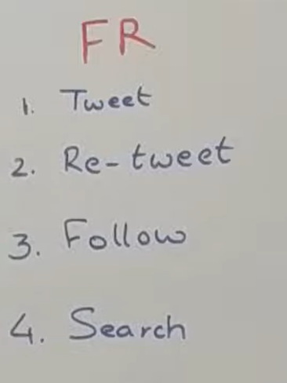

From the functional side the very first thing we should be able to tweet which is basically saying that we should be able to post a content of 140 characters length. It could have a image, it could have a video content , could have probably link to external website.

The second requirement is something called retweet so somebody if has tweeted something u should be able to retweet which is very similar to share on fb.

The next thing is we should be able to follow someone now that is directed a r/s. so If let say I follow user A does not mean that User A also follow me so that’s a unidirectional thing.

Search for some particular content within all the tweets that have been posted on twitter by some users this would be usually used to do some trend analysis or to figure out what happening in the world

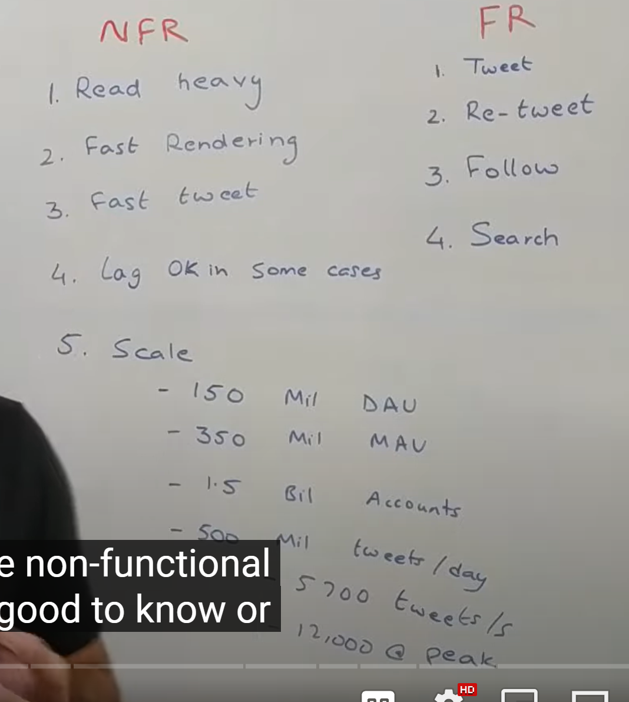

From the non functional side one of the very good to know it is very **read heavy platform.**

So let say user is posting something that is seen by lot of users. So for each write that is happening to system there are lot of reads that is happening . twitter has 100 time more read traffic compare to write traffic.

It should be able to **render very** fast. If somebody want to see home screen that should be render in less then a second. When u r **tweeting something** that flow should be fast . the system should have very low latency and at the same time it should always available. In some cases lag is ok like if somebody posted tweet it might be take to see it after 20 seconds. But whenever I see it , it should be rendering very fast

**Scale basic**

Twitter has 150 million daily access user

350 million monthly active user

Roughly 1.5 billion user accounts

500 millions tweet coming per day that is very massive number.

Roughly 5700 tweets coming every second on an average at peak load this number increases to 12000 number per second.

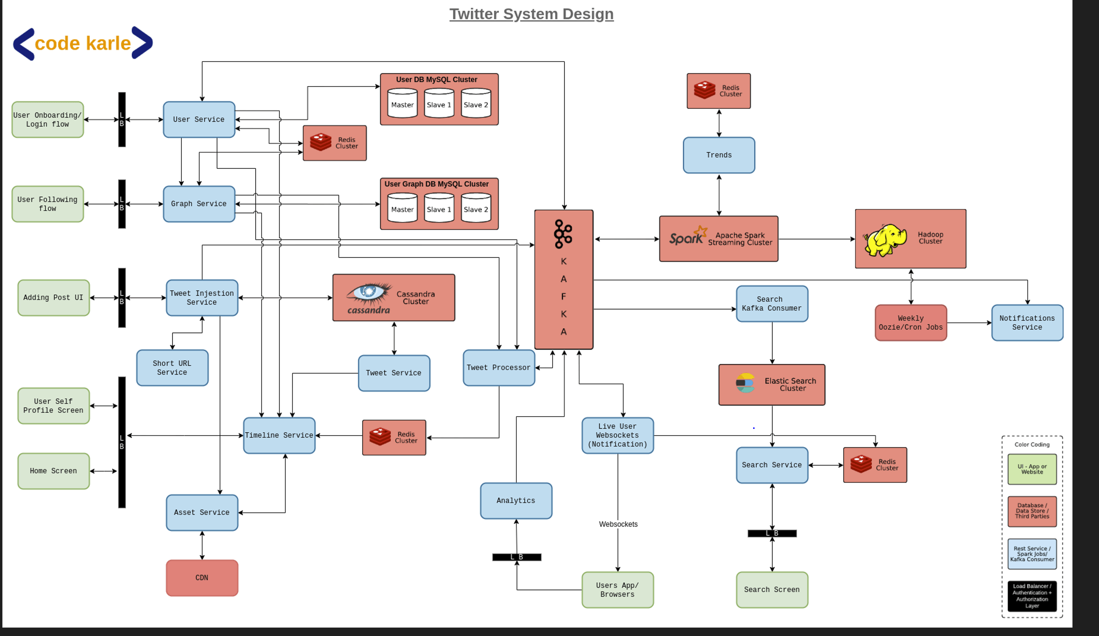

**Let now look how to design these system which can scale up to these numbers**

**First**  classify all of our users into some categories. We will be having 5 categories in which we will divide all user and then we will handle each category of user in slightly diff way.

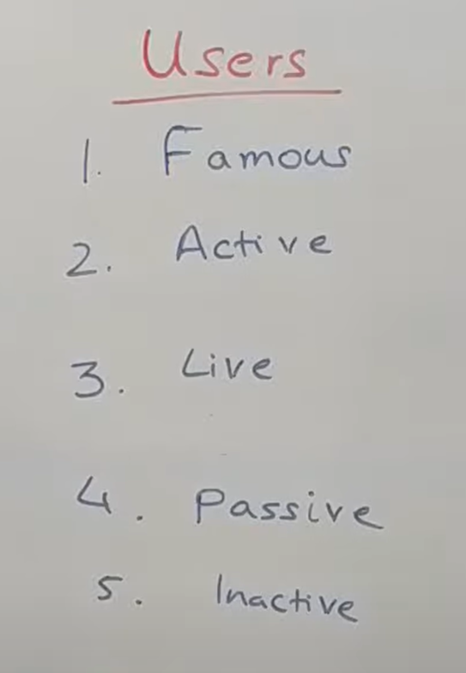

So the very first category something called as **famous users :**

these are the people who have huge number of followers in twitter

**Active users : definition**  changing but people access twitter in last couple of days or couple of hours.

Here will assume people access twitter in last 3 days are active users.

**Live user :**  these are the subset of active user and these are the people who accessing the platform right now. Something like online features of facebook or any other thing. As soon as person goes offline they moved back to **active status**

**Passive users : these**  are user who not fall in above category and these are the user who didn’t access in last 3 days and also not famous.

**Inactive users :**  basically deleted account. We don’t really delete a user. We do soft delete

**What is delete and soft delete?**

A soft delete marks a record as no longer active or valid without actually deleting it from the database.

**Lets look at overall architecture of the whole system**

Whole system is very big so divided it into **three component.**

The very first is user **onboarding flow** on how do they come into the system.

The next section would be **tweeting flow** which talks about how they post a tweet and how do they get various screen they have access to like their home screen and user screen and all of that

Next section will talk **abt search** and bit of analytics that we want to do

Note :

Whenever we designing a read heavy system in this case 100 x more read then number of write as much as possible we need to **precompute** information or **cache** some of the information

**Bit of convention :**

Everything in **green** is basically a user interaction point ( browser or mobile app).

Load balancer will authenticate api.

The thing in **blue** are the rest services or the web services or kafka consumer that we have written by our own.

The thing are in **red**  are either some cluster or d/b or some open source tool that u have used.

**Let start user Interaction :**

**which is onboarding process**  when they come in and register themselves on platform

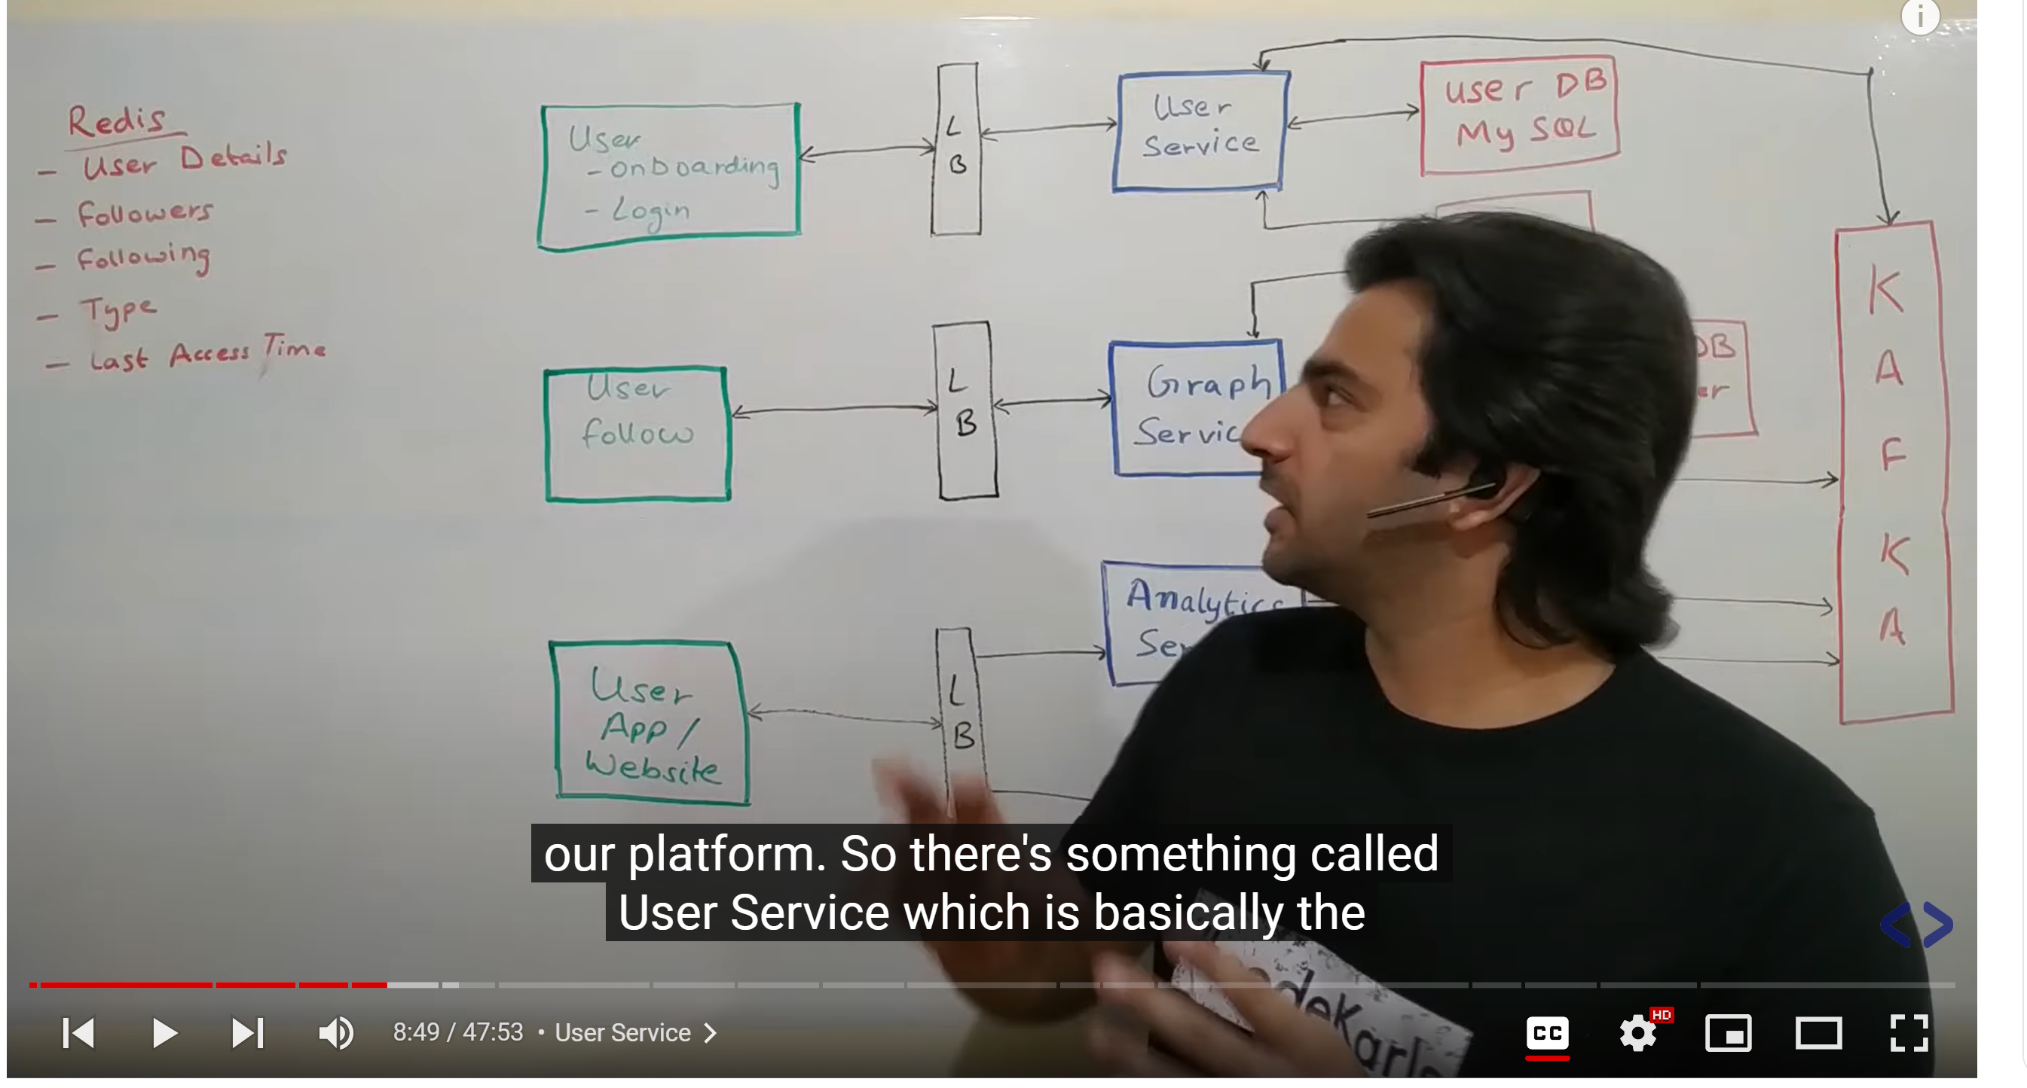

So there is something called **user service** which is basically the source of truth of all the user related information in our system. And that user service will powered the login flow, registered flow the user profile screen. The user service will also do a lot of internal tools and api required for serving internal tools. For example : if some other user want to get information about particular user they might want to query user service.

As per api concern it should have **get api** to get user details . it will have some **post api** to update the details of user. It should also have **bulk get api :**  to get information about lot of user like followers

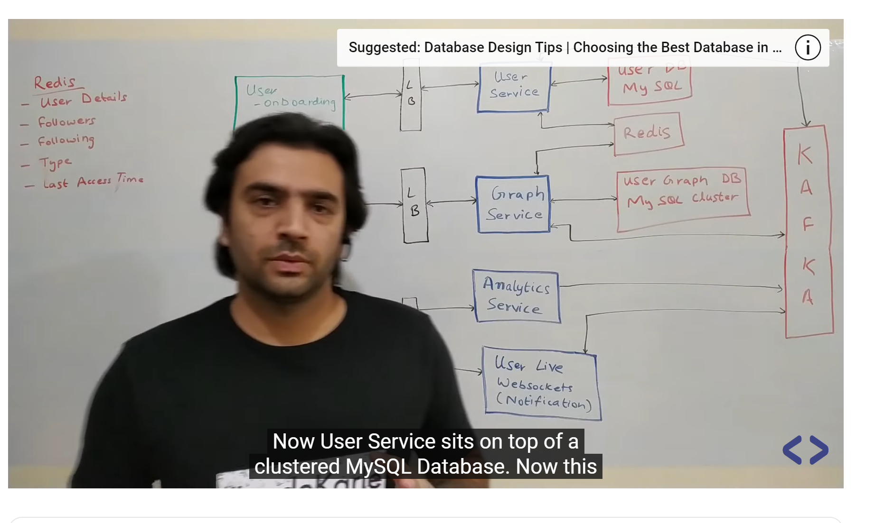

Now user service sit on top of clustered mysql d/b. this user information is very much relational information . from a scale standpoint it has million of users but they are still finite enough. And we will do certain optimization on this mysql so user info is a data which doesn’t change so frequently.

So this more of **a write heavy system**  and a bit of read do happen on it but read are mostly powered by a redis cache so redis cache is basically a image of a user d/b and which has a key of user id.

So whenever somebody hit user service to fetch details of a particular user it first tries to look up in redis that do I have information about the user . if it does not have it will query one of the read slaves of this user d/b get the information stored it into redis and respond back to the client. Now we have lot of information that is stored into redis

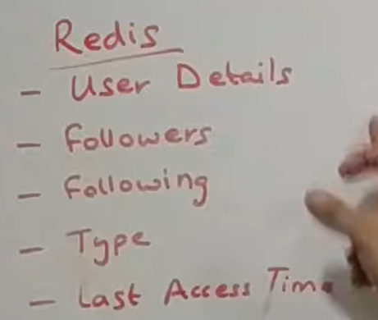

In all of last four key is user if and value is some object of this type.

**User follow process**

So  **any**  particular user of this platform can go to someone else profile and then follow them . they want to get certain kind of information like they want to know who do I follow or how many users follow me which is powered by something called **Graph service. A**gain graph service has lot of api.

Basically first of all to add a new follow link. It will also have api to get all the followers of a person and get all the people who this person is following. It will also have some bulk api which will get all the followers of list of users. It sit on top of another mysql d/b. now these are two different mysql cluster on which data would be residing. This would be fairly large data so will have to look probably at sharding that data. But think like logically one table which will have user id , follower id and a timestamp on which transaction happened there will be lot of other attributes but logically will have userId and a followerId. Again this is a data which does not updated very frequently that’s the reason to cache this info as well. **Now there are two kind of information we need to cache.**

First of all given a userId what are the list of users that this person follows which is basically the following thing and then given this user id who are the list of users that follows this particular user which is basically the followers of this user so these two information we are storing into same redis.

Again similar to user service all the api come to graph service first try to get from redis if they don’t find they query mysql they they persist into redis and respond back to the user.

**User app/ website**

So whenever a user is interacting with twitter they are sending certain signal even if they are not explicit so let say if they are browsing through a list of tweets that they go through and let say if they spend lot of time in one of the tweet , they are kind of telling that they are interested in this tweet. There are other information that we can gather based on the way people access the whole platform . so whenever we find some of the event of importance that is happening on the UI like browser , app we do send an event saying something happen just track it and then we can use it for analytics so all of event would be send through this load balancer to a service caller **analytics service** which will be putting into **kafka**.

**User live service websocket**  keep the connection open with all the live users and whenever any event happen (like someone follow) that need to be send to this user it happens via that websocket.

But how this will come play we will look into other section in details. Along with this we are capturing some other information as there is interaction b/w user and a server. We are basically capturing till how much time actually the user is live. All this info is also imp because if a a person not live we cannot send all kind of n/f and that information also need to get stored so that info will be put into kafka saying the user is not live anymore , **he was last live at a particular timestamp. That info will go all the way to user service it will stored in the cache saying**  **the**  user type has moved from a live user to active user. His last access time was some particular timestamp

Second component: **Now let try to looks at what happens when somebody post a tweets**

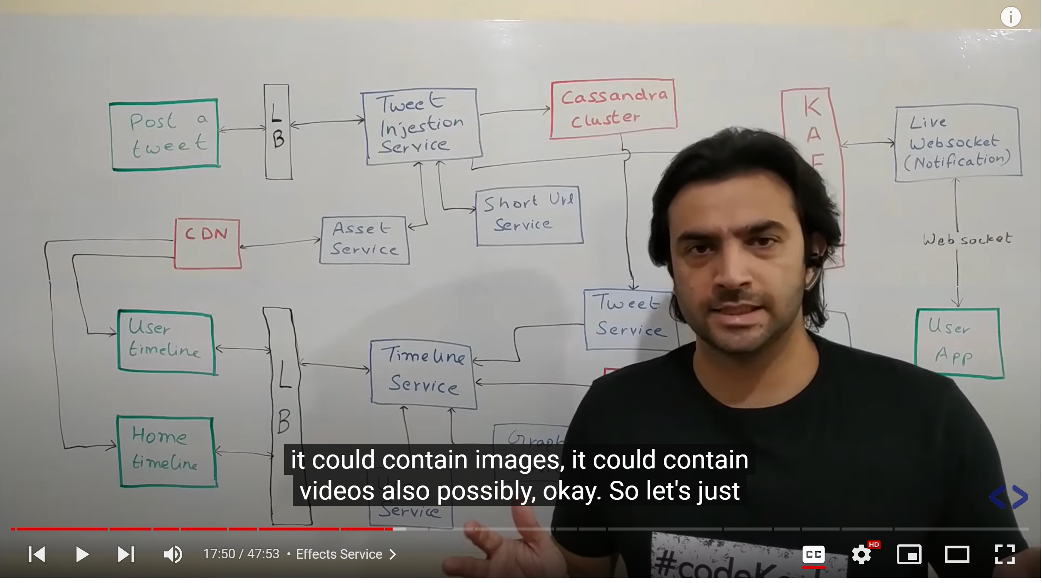

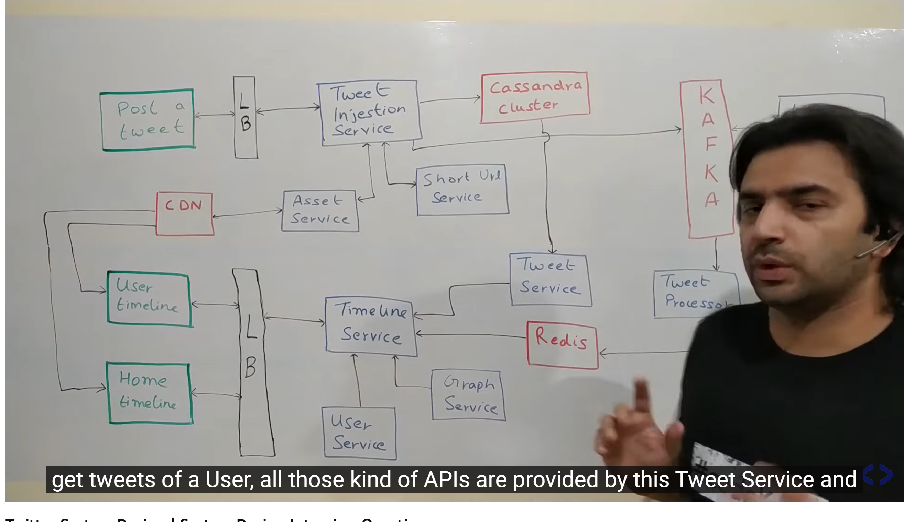

**T**weet means adding a new tweet , it could contain images , videos so let just say it could have image and video content we will be having something called an **Asset service**  what that it does it is responsible for all the multimedia content which could be video , images . it takes care of uploading wherever it need to and even somebody need to see it this is responsible for displaying the content.

Asset service is basically our video hosting platform now we just left with a tweet which will have text and couple of link(URL). Tweet text cannot big 140 character so first of all we **URL shortner** which will give a short URL instead of big url . assume it will take care on UI automatically and for backend we have short url service. Now assuming we have these two component (**asset service and url shortner) all**  now basically we have to handle storing a text of tweet and retrieving it when we need to so all of that functionality will go into **tweet injection service so**  each time a person posted a tweet basically type a text hits the submit button that makes a call to tweet injection service which first of all the very first thing it does is stores it in a permanent datastore . we are using **Cassandra** for storing the tweets why because we have a massive amount of data . **hbase** also we can use here but set up of Cassandra is fairly easy and for set up of hbase we need zookeeper and Hadoop cluster that add a lot of maintenance. Assuming Cassandra having table which has tweet table which has tweet id , userId who posted the tweet and tweet content and a couple of other attributes. So this how structure would look like. **Tweet injection service**  is just responsible for posting a tweet. It doesn’t provide a get API and all of that. Once it has posted to Cassandra what it does is it puts a event into **kafka**  **saying I**  have got a new tweet whose tweet id and so on whatever the id is which is auto generated by tweet injection service it has been posted by this user id and this is the content. **So this tweet injection service put this message into kafka**  **and the flow of tweet injection**  is over. So this is how we saved the tweet.

So there is **tweet Service**  **I h**ave this is basically source of truth service for all the tweets so this basically sit on top of this Cassandra cluster and own the schema and data within that. This tweet service will provide all set of API that you need to display any tweet. So get by tweet id , get tweets of a user all those kind of api are provided by this tweet service and whenever somebody timeline need to be generated this is also powered by this tweet service.

**What is timeline used?**

A timeline is a tool that organizes information. It is used **to describe the order in which events happened**. Timelines can also help show how events in history are related. A timeline can cover a short amount of time in great detail, or it can offer a more general overview of a long period of time.

**Now for a second quickly jumping on the user side of things**. So when somebody want to looks at the tweet on the read  flow there are two kind of views that a person can have . one is called a **User timeline**  which is basically a series of tweets ordered by something generally by timestamps. Now user timeline is basically your own timeline . this basically contain all the tweet all the retweets that you have posted. Then there is something called **home timeline.**  What we see on home page.

So all the people that you are following all their tweets will show in home timeline. It will slow down Cassandra if we start querying Cassandra for each thing so we will **cache user timeline.**

We will say that we know there are some active users who will come on website. Instead of calculating at runtime we precalculate all of their timelines and just show it to them .

Whenever a person tweet something which is going to kafka so now there is a **tweet processor.**

It basically sees that user1 has tweeted something now let me try to get their followers and lets say it figure out there are some users whose timeline need to be updated because this tweet will now show up in all of those user’s timeline. Then it will create timeline for all of those users and put it in this cache(redis) so now when user try to come on their home screen they just do a cache look up and there view is sorted so If I just have to list down things it basically is something like let say **user u1 posted a tweet t1 and u1 is followed by let say u2 , u3 and u4**  so what tweet processor does is it basically in the timeline of user u2,u3,u4 it puts tweet t1 along with that what all other tweets it had. Similarly lot of users posting tweets so all the tweets coming here this tweet processor service is identifying all the followers and whole of that mapping and updating all of people timelines . now basically this service need to get list of all people who are being followed. So for that it will query **graph service. Tweet**  processor will query the graph service to figure out all the users basically this u1 to this u2,u3,u4 mapping . this will be queried from the graph service .

But there **are lot of problem** in this design. The problem are because we are maintaining everything in redis . Redis first of all is **in memory solution** so it will put all the data in memory. What that meant is we need massive amount of RAM. Now if we try to keep timelines of all the user in memory that something very inefficient. So only those users of timeline would be stored into redis who are active. That is one side of problem.

Now what happens if **passive user** come in and want to see their timeline. So in that scenario all the request from this home timeline will come to timeline service . timeline service will query redis for all the active user . it is easy to figure out who are active user by querying **user service**  **which**  anyway has user to type mapping in its own cache. Now once timeline service figures out that the user is a passive user and I do have it data in redis . what it will do it essentially query whoever it need to in the system try to figure out all the data it needs to figure out and then it creates the timeline so what it does is essentially it first of all queries **graph service** saying that I have got this new user whose timeline I need to create . give me all the users who this user follows so it get a list of user whose tweets would now be shown then it queries that **tweet service**  to give all the tweets of all of the users. Once it get all the tweets of all those users it now arrange them as per timeline as per the timestamp store it back in the redis and return to the UI. So now we have solution to handle active users and passive users. Now once active and passive users are handed we could do some kind of optimization for the live users. Tweet processor anyone knows who all timelines need to be updated. **Once the tweet processor is figure out that a particular timeline is to be updated and it figures out it a live user it actually put back event back to kafka**  and then comes the live **websocket** thing. It just check if user is live this will actually send n/f to the app.

Again reiterating over the flow. An event comes to kafka tweet processor tries to update Redis but while updating redis it will also get to know that this user is a live user so it will put back an event into kafka saying whoever is responsible for sending this n/f down to the user go send right away. Don’t wait for the person to query back. Through this route it will come to user app and the UX should be able to handle it saying u have more tweets just scroll up or down and something of that sort. So now even live user they don’t need to query redis while they are on the app they keep getting those n/f and newer tweet will just keep showing on their UI.

But still has lot of problem see Donald trump has roughly 75 million follower.

**Timeline service** will take care of merging everything( for famous user) so timeline service knows redis has data only of tweets of normal users. So once it get the data of all the users it now  **tries to figure out**  that what are the tweets that should be shown to this user of famous user. So timeline service basically query graph service again and try to figure out who are the famous user that this person was following and get their tweets as well. Now timeline service after querying from graph service through tweet service has all the tweet of a person like Donald trump. Timeline service has also the tweets of the normal user and it can show it the UI.

**Inactive user : deactivated account :**  they cant even login

There are certain famous user who follow some other famous user. Both of their tweets will not go the redis route normally but if one famous user tweet other famous user must get notified.

Whenever Famous user tweet come in don’t update the cache of all user but update the cache of other famous user that will be handled by tweet processor.

**Bottleneck here**

**Cassnadra**

**Redis**

**Kafka**

**We**  should have enough TTL on redis we really don’t want to keep junk data.

Cassandra , redia and kafka are horizontally scalable as when number of tweets increases we need to add more machines into each of these components.

**Third component**

Coming to the last part search and analytics. Let first look how search work.

So by search what we mean it if somebody want to search for a particular text we want to show them all the tweets that have that particular string in that ordered by some relevance score.

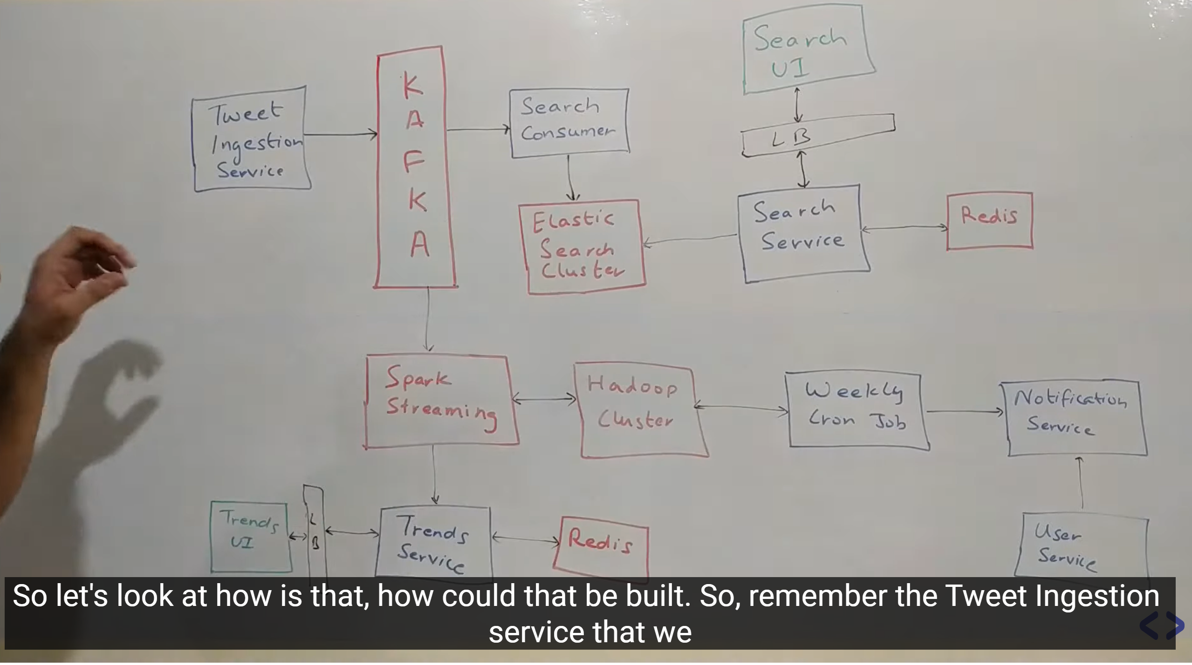

Tweet injection service was basically the entry point of all the tweets into our system and it used to put a event into kafka which was read by service for putting into redis. Now there are lot of other consumer who are consuming the same data (kafka data). One of such consumer is a **search consumer.**  It basically look at all the tweets basically consumes all the tweets that are coming into the system and stores it into a d/b which is used for searching and it uses a d/b called elastic search which is clustered nosql d/b very efficient for text based searching . now once search consumer processes all the data and stored it into elasticsearch it is ready for search . now coming to user side of thing . a user can then basically give a search string as an input which would come through this search UI it would talk to a load a balancer and talk to this search service now **search service**  would then query elasticsearch get the results and give it back to user. Search service and search consumer are very well aware of the contract. So consumer is basically the writing and search service reading from the data store.

**Now we go over NFR**

Once search service get us a set of result from elastic search it will put it in the redis with a time to live (TTL) let say 3 min so for 3 min we will have that search result after that it will expire now instead of querying elasticsearch search service when it get a request it will first query redis if it get a result well and good it will return then and there and if does not get a result it will then query elasticsearch get the search result store it in redis and then respond back so by adding it into redis we will effectively reduce lot of loads on elasticsearch and which include computation cost and effectively redis must cheaper here.

**Now let look at some of the analytics at the top of this data**

Again going back to same same kafka where series of tweet were coming . we want to know what is trending or what people is talking about. What we could easily do this on top of this kafka have a very simple **spark streaming consumer** running which basically just check what were the most common keywords in last one hour. It will store all the tweet somewhere and split it into word and check last one hour which is more use. And check trending type of thing so we have a **trend service**

**Which**  spark streaming will write let say every half an hour and there can be a **trend UI**  which build on top of this service . as a storage we don’t need this permanently we could use redis for storing. We have lot of redis but we can store on disk as well. These trend we can also calculate at geographical level what india people talking about.

Now let say all the tweet we have we might put into **Hadoop cluster because**  in a company like twitter scale there would be lot of analytics done. So like which user tweet is most retweet all kind of various query can be answer by querying on Hadoop. There are lot of newsletter which send weekly about various thing twitter also send that. It could be business some promotion. Let see an example let say we have weekly cron job which is basically responsible to pull back all the passive users. So passive users are the ones who are not using platform frequently and it is good for twitter to start using it so to engage those user twitter could start a weekly email which talks about some of the very popular tweets in the last one week. So there could be ML kind of thing for which passive user what are the most relevant tweet in the last 7 days that this person would be interested in. get the list of top 5 tweets and send them n/f saying these are the tweets u missed so why u don’t come on platform. Now how n/f would be sent there would be n/f service that will be invoked saying this is the user these are the tweets go send the content. **The n/f service** can talk to **user service to get**  the email id , phone number etc.

So lot of thing here are store in memory but if let say 5 time scale increases then how will manage all those thing explain in design of f/b